Nama : Siti Fauziyah

NIM : 18090019

Kelas : 5B

**Laporan Pratikum 3**

1. Source Code

Data-form-matakuliah.php → view

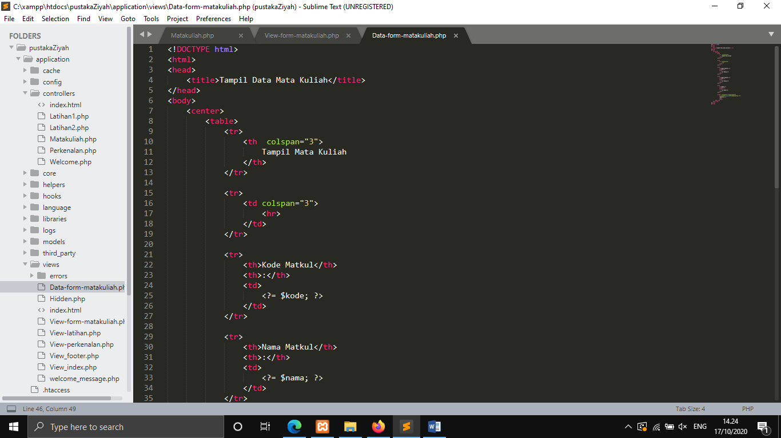

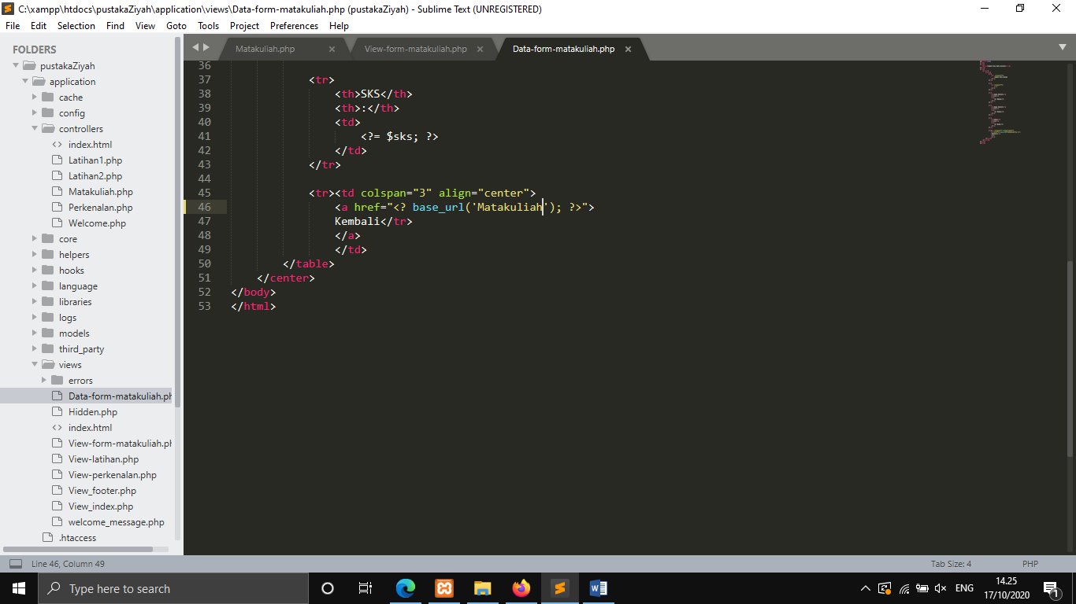

View-form-matakuliah.php → view

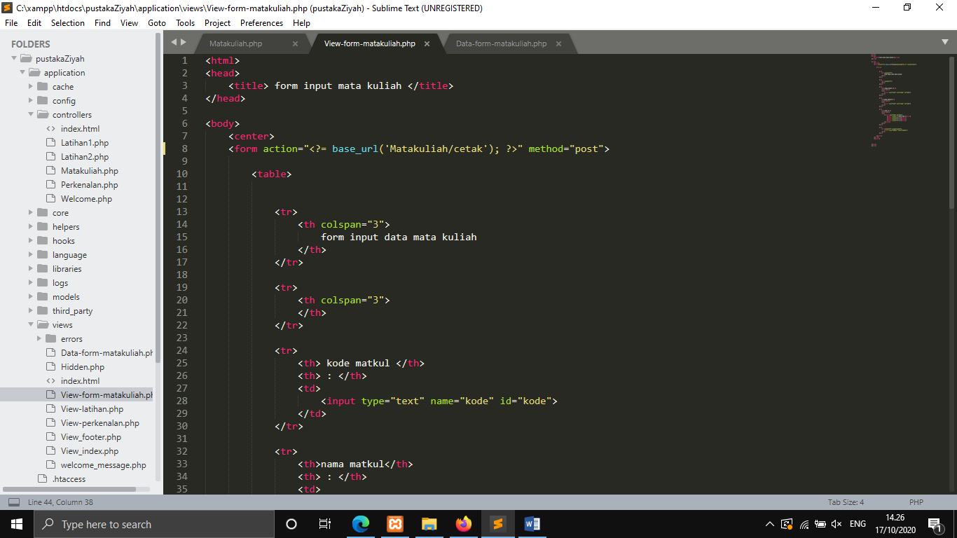

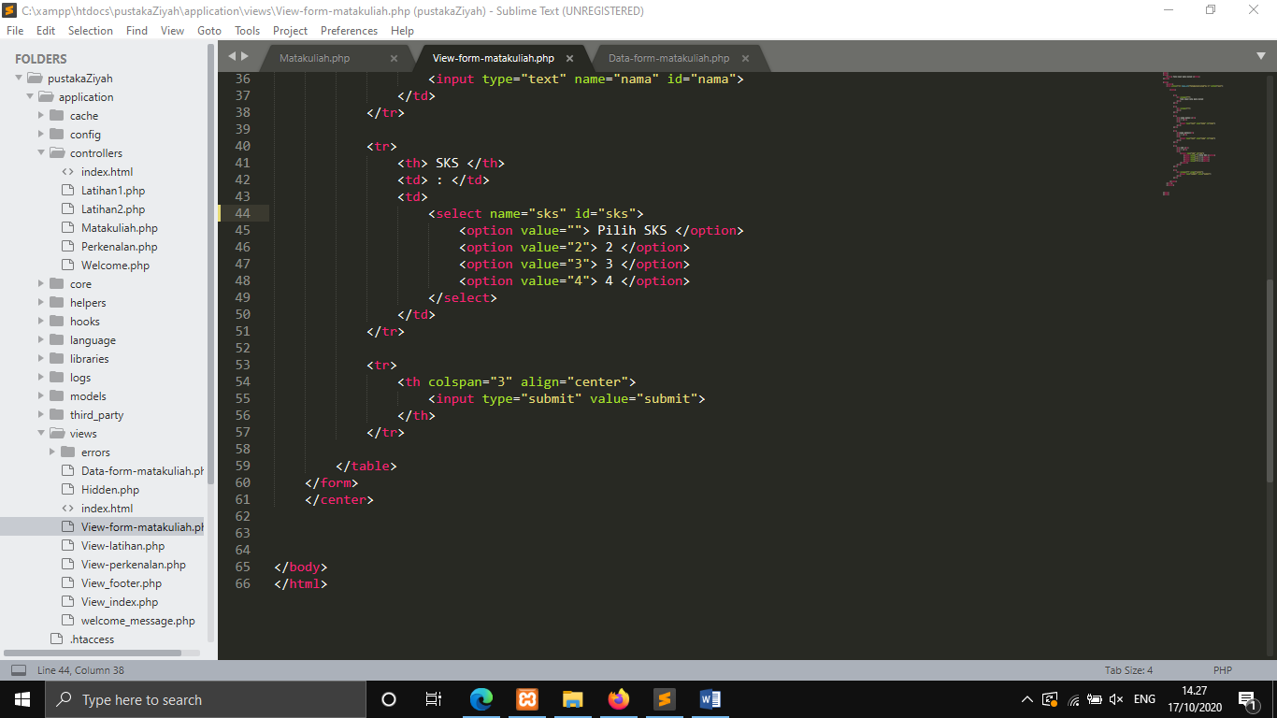

Matakuliah.php → controllers

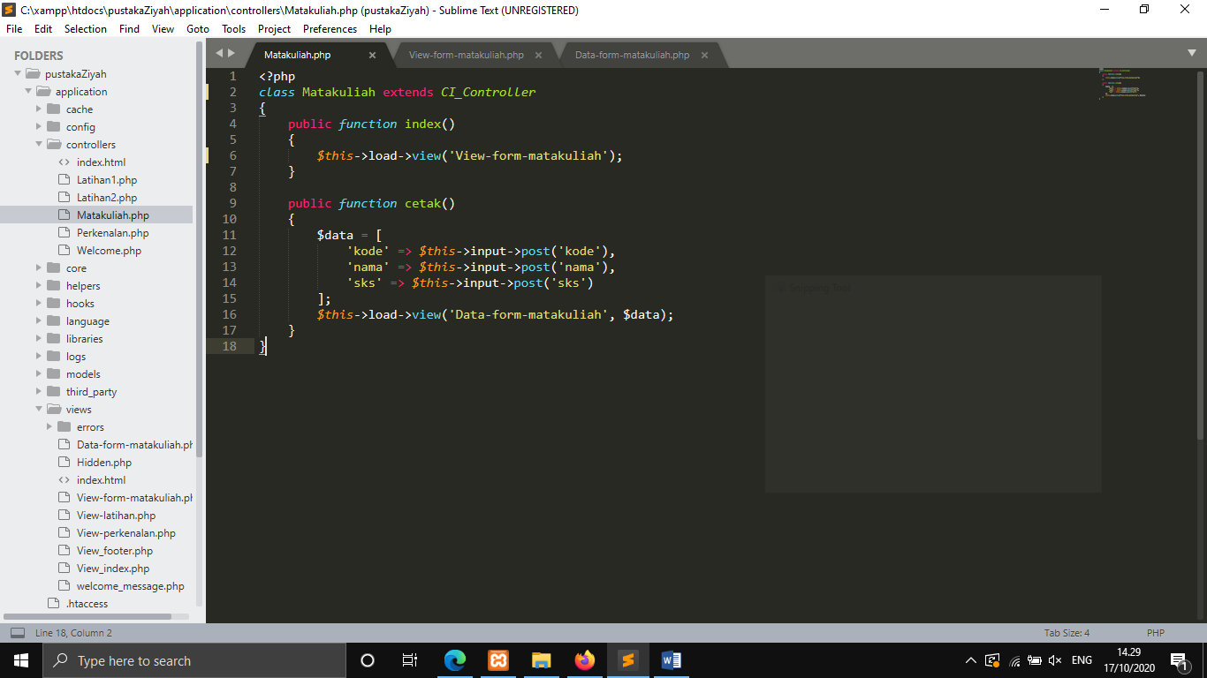

1. URL

<http://localhost/pustakaZiyah/Matakuliah>

<http://localhost/pustakaZiyah/Matakuliah/cetak>

1. Capture Output Program

